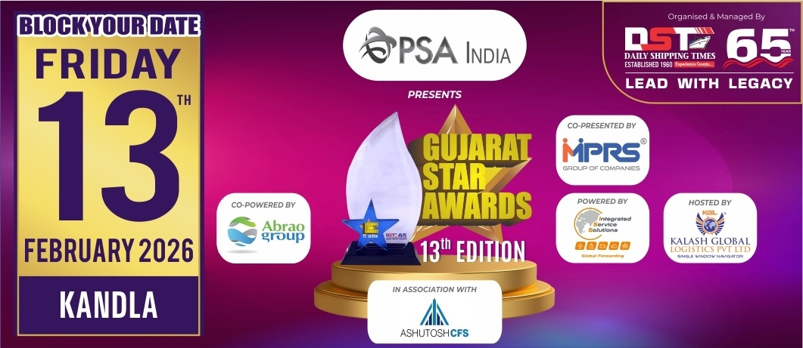
Nomination Form
Information should be relevant to
FY 2024-25 & for Gujarat Region only
(Jury Chairman will disqualify the papers if it is not related to Gujarat)
Note : Please mail back the details on nominations@gujaratstarawards.com

Award Category : BEST CUSTOMS BROKER OF THE YEAR – BREAKBULK

Award Criteria :-
Number of B/E & S/B Filed, Volume handled in MT, Year on Year Growth &
Customer Satisfaction.
Please Note : Last date for Filing Nomination is 3rd November, 2025

Contact Information :-

Name of the Company :-
Contact Person :-
Designation :-
Contact No. :-
Email Address :-

Number of B/E & S/B Filed :-

Volume handled in MT (April 2024 to March 2025) :-

Year on Year Growth (Kindly mention figures for Last 3 years & growth percentage) :-

YEAR VOLUME GROWTH %
2024-2025

2023-2024

2022-2023

Customer Satisfaction (Maximum 5 letters) :-

